IST722: Class Exercise 8

**This is an individual assignment.**

**Before you begin, please make sure you’ve read and understand 1) our class honor code, 2) course policies on late work and 3) participation policies as posted on the syllabus. “I didn’t know” is not an excuse.**

**You should cite your sources in a standard format like MPA or APA and include a list of works cited.**

|  |  |
| --- | --- |
| Your Name: | Yunhan Zhang |
| Your Email: | yzhan297@syr.edu |

# Instructions (Refer Unit 8)

Answer each of the following questions as concisely as possible. More is not necessarily better. Please justify your answer by citing your sources from the assigned readings from our textbooks, our class lectures, or online if directed to do so. Be sure to cite in text and include a list of works cited. Place your answer below each question. When you’re finished, print out this document and bring it to class as part of your participation grade.

# Questions

[1] What is Data Quality? List three types of DQ rules with examples.

Data Quality is activity to ensure all of the data in the warehouse is correct and complete so that we can trust the data located in the data warehouse.

Three types of DQ rules:

1. Incoming data validation – Phone number should be only 10 digits.
2. Cross Reference validation – Any kind of restrictions of login to a single website.
3. Data warehouse internal validation – Yearly sales in summary table matches the actual number of sales by year.

[2] What is the Data Cleaning requirement? Can you perform Analytics with Dirty Data?

It is a process of fixing or removing the incorrect, corrupted, wrong formatted, duplicate or incomplete data within a dataset. No, we can’t perform Analytics with dirty data.

[3] What is Master Data? How is this different from DW Dimensions?

It is the main entity of the organization which maintains central copy of the organization’s data. Master data stores the union of the entity data which is available as compared to dimension data which stores data relevant to the business process.

[4] How can a company benefit from Master Data Management? Does every company need an MDM strategy?

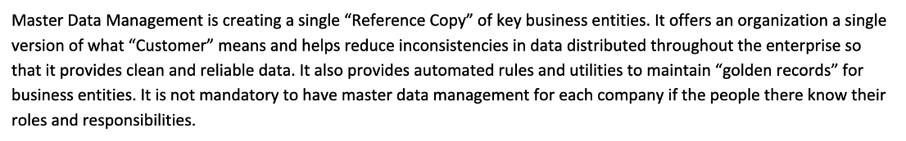

[5] Describe the composition and function of a data governance board.

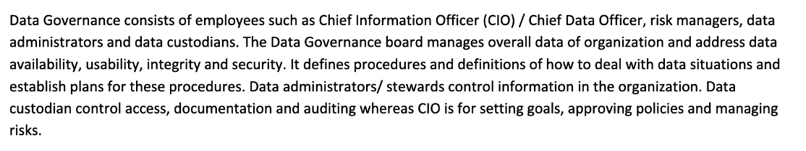

WORKS CITED:

**Professor Fudge’s video and slides.**